**First Review**

**Predictive analysis of city based crops using Internet of Things based Hydroponic system**

S A Hariprasad

18BCE0868

9444115062

Sa.hariprasad2018@vitstudent.ac.in

Nikhil K

18BCE2321

8897795645

kavuru.nikhil2018@vitstudent.ac.in

Yokesh Babu S

Assistant Professor(Selection Grade)

9600205336

Yokeshbabu.s@vit.ac.in

**B.Tech.**

in

**Computer Science and Engineering**

**School of Computer Science & Engineering**

**®**



**Abstract:**

In a rapidly developing country like India, which has the world’s highest growing GDP Urbanization is being seen in every nuke and corner of the country. The difference between the population density of the cities and rural areas are very high. The population of the cities are growing exponentially every year, because of which the agricultural farms in and around the cities are being converted into residential sky scrapers. The need and demand for crops and food is growing up but the area to grow is going down. Due to this alarming scenario, hydropic agriculture has risen in popularity and practice. It is a form of agriculture in which the plants are grown with restricted water supply. In this work, we are growing coriander plant in a controlled environment with constant monitoring, the controlled environment being restricted water supply I,e Hydroponic farming. Various parameters like Soil pH, Moisture levels etc. are recorded on daily basis and made into a data set. This data set, then  with the help of Supervised Machine Learning algorithms we are going to Co-Relate the data collected via IOT by the help of Regression Models ,find the trends within the taken parameters and give an idea as to which conditions give a better yield.

***Keywords*: Supervised Machine Learning Algorithms, Regression Models, Controlled Environment, Hydroponic, Urbanization**

**Introduction:**

Agriculture is the primary occupation in India and is the backbone of Indian economic system. Agriculture provides employment opportunities to rural people on a large scale in underdeveloped and developing countries in addition to providing food. It is the process of producing food, fibre and many other desired products by the cultivation and raising of domestic animals. Agriculture is the primary source of livelihood for about more than 58% of India’s population.

As the population of the city grows significantly the need to feed the city heavily lays on the need of agricultural land. As most of the agriculture lands are dried up due to lack of water the need for starvation increases. Hence cities have to start cultivating crops and the need for automated farming in cities becomes crucial.

Climate changes will have a significant impact on agriculture by increasing water demand and limiting crop productivity in areas where irrigation is most needed. Irrigation system, rain fed agriculture, groundwater irrigation are some of the methods introduced to produce healthier crops which may not use water efficiently. In order to use water efficiently a smart system is designed. In the system farmers need not make the water flow into fields manually, but the system automatically does that efficiently.

The traditional methods practiced by people may result in huge wastage of water. Hence, the concept of robotized farming with a mix of IoT has been developed. The technological advancements began to increase the efficiency of production remarkably thus, making it a reliable system. The knowledge of properties of soil determines the water supply to be driven in a smart way. The practice of agriculture in a smart way helps to acquire knowledge of soil and temperature conditions. Developing the smart agriculture using IoT based systems not only increases the production but also avoids wastage of water

**Objective:**

The main objective of our work is to find and show the correlation between various parameters take into account while growing a crop through hydroponic agriculture and predict the range of parameters which result in the best growth of the crops.

**Problem Statement:**

In this fast paced world the population in metropolitan Cities is growing exponentially. This is due to both ecological factors and also migration into the cities because of urbanization  for a better lifestyle which is directly proportional to the rise in population density. With increasing urbanization and depleting natural resources, it is getting very difficult to satisfy the  very basic needs of the population. With cities expanding, Once agricultural land is now being made into real estate for development which in turn is leading to scarcity of staple foods.

This is the main reason why there is a rise in demand for hydropic and other forms of sustainable agriculture.

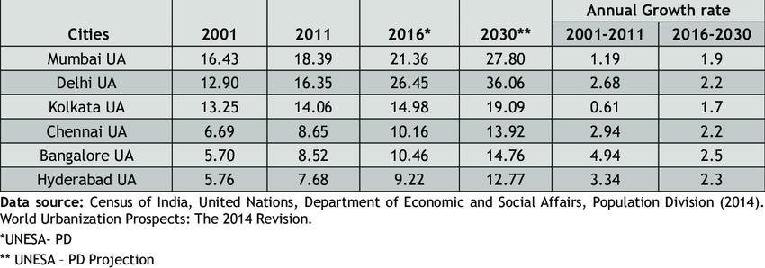

Figure : Exponential growth in metropolitan cities in India

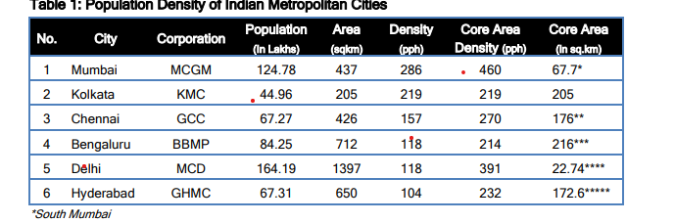

Figure :The population density in Indian metropolitan cities

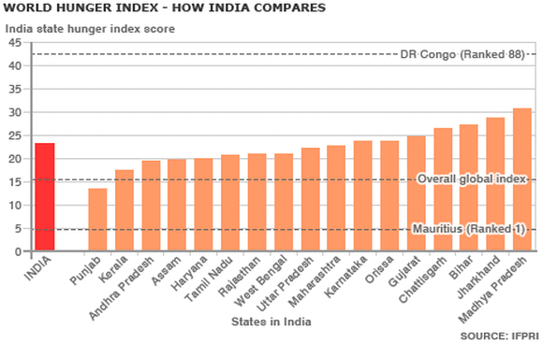

Figure :World Hunger Index in India

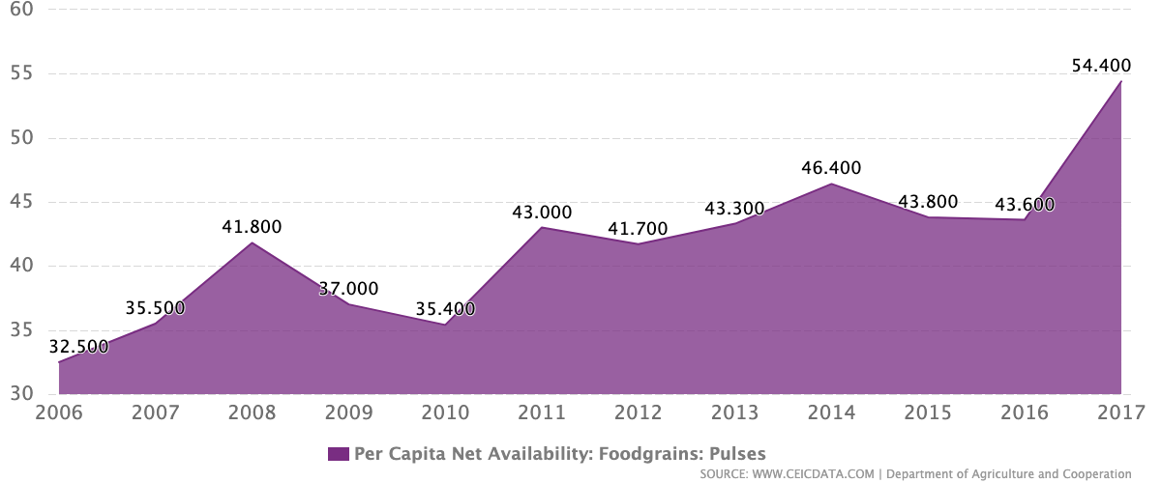

Figure :Per capita Net Availability in India

**Literature Survey**:

|  |  |  |  |  |
| --- | --- | --- | --- | --- |
| S.No | Title | Authors | Methodologies Used | Drawbacks and Future Works |
| 1 | Data Acquisition and Actuation for Aquaponics using  IoT | Akhil Nicani, Sayantan Saha, Tushar Upadhyay, A. Ramya,  Maulin Tolia | Multi-Level IOT framework, which uses Application Layer, Internet Layer, Sensor and Actuator Framework along with Distribution middleware and follows MQTT protocol.  In the output, the End User Experiences VPS interaction in one aspect and in the other aspect, it uses VPS and Local Server Interaction | This works falls back in implementing limiting factors such as nitrate, nitrate and ammonia via the electronic sensors.  Automated data collection can be implemented into this work so that the system can function with better efficiency and maybe it could send alerts to the sender if there is any change or drastic changes in the parameters. |
| 2 | An eye on hydroponics: The IoT initiative | Joshitha C,  P Kanakaraja,  Sarath Kumar,  Polavarapu Akanksha,  Guduru Satish | The paper focuses on five main concepts, namely  Hydroponics, Need for Automation Control, Climate Statistics, Data Analytics and Cloud, Proposed System.  The sensors record analog Data through Hydroponic system with the help of MCP 3008 ADC. | This work acts as an eye mainly to farmers but this technology can sometimes act more of an ban than a boon for the farmers.  This work is done solely done on the famer end so, it can be implemented in other factors as well |
| 3 | A Controlled Environment Agriculture with  Hydroponics: Variants, Parameters, Methodologies  and Challenges for Smart Farming | Srivani P,  Yammuna Devi C,  Manjula S H | The most innovative and peculiar aspect of this work is the growth of crops in an Controlled Environment Agricultural System(CEA) rather than the natural growth environment for the best growth.  Uses a four step architecture in which Sensor system, Data Processing System, Communication Device and Cloud Storage systems are used. | The major drawback of this work is the usage of CEA which stands for Controlled Environment Agriculture System.  Due to this, even though the work uses multiple regression models to predict the best conditions, it will not always give the best results as the criteria set are standard and always idealistic.  As it is set for Controlled environment, the power usage will be very high and can’t be implemented on a large scale. |
| 4 | Predictive models for Lettuce quality from Internet of  Things-based hydroponic farm. | Sethavidh Gertphol, Pariyanuj Chulaka,  Tanabut Changmai | This paper works on the growth of Lettuce in a controlled environment with the help of IoT, In a market where lettuce is not a commodity but a luxury. RMSE is one of the model used for model selection.  SVR, MLR and ANN are used for each weeks prediction.  They used SCIKIT in four steps, namely  Preparing Data and Normalising, Processing etc.. | Feature Selection has not yet been used in the creation of the machine learning model in this study. As a result, the outcome was less than satisfactory. The lettuce was standing straight one day and swaying to the side the next due to the blowing wind. Other errors were influenced by the amount of sunlight and temperature on that particular day. A lot of sunlight causes the plant to wither and unfold. When measured on a day with less sunlight and temperature, the width is smaller than when measured on a day with more sunlight and temperature. Finally, these flaws caused the model to fail to produce a good learning result. |
| 5 | A Study on IoT based Low-Cost Smart Kit  for Coconut Farm Management | S. Jaisankar, P.Nalini,  K. Krishna Rubigha | This work is concentrated on an innovative way to solve problem which is specific to Coconut farm owners.  A coco smart-kit is installed in every farm and it is linked to farmers smartphones.  It is a theoretical solution which helps in solving the following situations,  Safeguarding the coconut trees from wild animals,  Distribution of available water covering the fields,  Preventing the pests from coconut trees. | The main drawback of this work is the lack of experimentation, it is all in a theoretical stance so, scalability might be of major concern.  For this to work, every farmer must own a smartphone which is practically not possible as the farmers are not inclined towards technology.  For a total of 10 sensors, which include Fence alarm, Moisture sensor, Pest Sensor, Valve Control and GSM module, it costs Rs. 113.5 but in large scale, 10 sensors are not nearly enough to cover the whole field. With the help of generalising the coconut farm size in India, we would require around 1250 sensors which would cost around Rs 14000 for an Acer of Coconut farms which is not very cost effective. |
| 6 | A Survey on the Role of IoT in Agriculture for  the Implementation of Smart Farming | MUHAMMAD SHOAIB FAROOQ, SHAMYLA RIAZ, ADNAN ABID,  KAMRAN ABID, MUHAMMAD AZHAR NAEEM | As it is a Survey paper, it takes a closer look at various paper and gives us an idea on various uses of IoT in agriculture across the globe.  It talks about various agricultural Challenges such as the Hardware Challenges, Networking Challenges and the Networking Challenges.  Also discussed about various agricultural Security treats with IoT such as Confidentiality, Integrity, Authentication, Data freshness, Non repudiation, Authorisations, self-healing etc. along with Stack Challenges, Threat Models, Attack Taxonomy  And so on | As the work is a literature Survey, there are no drawbacks per say |
| 7 | IoT Based Smart Farming: Are the LPWAN  Technologies Suitable for Remote Communication? | Nahina Islam,  Biplob Ray,  Faezeh Pasandideh | This work emphasises on the importance of IoT based technologies in agriculture. This paper works on the use of Low-Power Wide-Area Network(LPWAN) to reduce the power consumption and increasing the wireless range by eliminating the unnecessary dependency of third party and backhaul networks.  It also describes the comparisons between Coverage Range, Quality of Service, Battery Life, Latency, Scalability, Payload Length and Development model between LPWAN technologies. | The only major drawback of the paper is the maintenance the LPWAN requires to keep it running as the technology used won’t have the ideal conditions to run in an agricultural setup even though the batter life and power consumption are ideal. |
| 8 | IoT for Smart Farm: A Case Study of the Fertilizer  Mixer Prototype | Sumarn Chaikhamwang,  Chalida Janthajirakowit,  Srinuan Fongmanee | The main research output of the work is to develop an application with the help of IoT to Control the fertilizer mixer. The work is split into two parts, being the hardware part which uses ESP32S platform for controlling devices and controlling applications and the software aspect helps the user to chose the right mixture of N-P-K by setting the required ratios of N,P and K. | The main drawbacks of this work are, when selecting the NPK values for the mixture, there is no option to shut off the process midway so, a shutoff valve can be implemented.  The prototype made uses high grade plastic as it doesn’t react with the chemicals but Non-reactive metals can be used for durability.  Lastly, the sensors used, are giving an output with less precession than the optimal so, high precession sensors can be used. |
| 9 | Low-cost IoT+ML design for smart farming with multiple  applications | Fahad K Sayed,  Agniswar Paul,  Ajay Kumar,  Jaideep Cherukuri | This work focuses on a model which maintains soil moisture level which is optimum for the crop growth.  This level of soil moisture will be maintained constantly for the next 24 hours with no impact and consideration of the weather condition.  This work also talks about smart irrigation system which helps in apt water management and provides ideal crop suggestions based on historic soil data.  This work also provides the type and quantity of various minerals needed. | This work does not talk about the plant diseases, this can further be extended so as to detect diseases and automated dispersal of pesticides and insecticides.  While maintaining the soil moisture levels, the weather condition is not taken into account because of which plant growth is affected in a adverse way. |

**Conclusion:**

In the current stage of our project we have implemented a hydroponic system to cultivate coriander crop where we are collecting data parameters such as ph value, temperature, humidity, soil moisture, and water level in the system. We are planning to collect data till the plant reaches its full growth and we will be analysing the trends in data using regression model and data analysis. After analysing the data we will be able to implement a prototype that can help people grow crops in cities through automation and improve more cultivation in urban areas. Hydroponic systems are going to become the future of agriculture in urban areas and help farmers to reduce the burden to provide food to urban regions.

**Reference:**

Weblinks:

1.https://www.thebetterindia.com/265317/uttar-pradesh-hydroponics-farm-home-grows-vegetables-fruits-earns-lakhs/

2.https://www.thebetterindia.com/265639/sandeep-kannan-vyavasai-bhoomi-tirupati-hydroponics-startup-farmer-success-story/

3.https://www.expresspharma.in/hydroponics-market-expected-to-grow-at-a-cagr-of-about-26-per-cent-by-2023/

4. https://krishijagran.com/agripedia/why-hydroponic-farms-are-trending-in-india/

Journal:

1. A. Nichani, S. Saha, T. Upadhyay, A. Ramya and M. Tolia, "Data Acquisition and Actuation for Aquaponics using IoT," 2018 3rd IEEE International Conference on Recent Trends in Electronics, Information & Communication Technology (RTEICT), 2018, pp. 46-51, doi: 10.1109/RTEICT42901.2018.9012260.

2. H. K. Srinidhi, H. S. Shreenidhi and G. S. Vishnu, "Smart Hydroponics system integrating with IoT and Machine learning algorithm," 2020 International Conference on Recent Trends on Electronics, Information, Communication & Technology (RTEICT), 2020, pp. 261-264, doi: 10.1109/RTEICT49044.2020.9315549.

3. P. Srivani, Y. Devi C. and S. H. Manjula, "A Controlled Environment Agriculture with Hydroponics: Variants, Parameters, Methodologies and Challenges for Smart Farming," 2019 Fifteenth International Conference on Information Processing (ICINPRO), 2019, pp. 1-8, doi: 10.1109/ICInPro47689.2019.9092043.

4. C. Joshitha, P. Kanakaraja, K. S. Kumar, P. Akanksha and G. Satish, "An eye on hydroponics: The IoT initiative," 2021 7th International Conference on Electrical Energy Systems (ICEES), 2021, pp. 553-557, doi: 10.1109/ICEES51510.2021.9383694.

5. S. Gertphol, P. Chulaka and T. Changmai, "Predictive models for Lettuce quality from Internet of Things-based hydroponic farm," 2018 22nd International Computer Science and Engineering Conference (ICSEC), 2018, pp. 1-5, doi: 10.1109/ICSEC.2018.8712676.

6. S. Jaisankar, P. Nalini and K. K. Rubigha, "A Study on IoT based Low-Cost Smart Kit for Coconut Farm Management," 2020 Fourth International Conference on I-SMAC (IoT in Social, Mobile, Analytics and Cloud) (I-SMAC), 2020, pp. 161-165, doi: 10.1109/I-SMAC49090.2020.9243486.

7. M. S. Farooq, S. Riaz, A. Abid, K. Abid and M. A. Naeem, "A Survey on the Role of IoT in Agriculture for the Implementation of Smart Farming," in IEEE Access, vol. 7, pp. 156237-156271, 2019, doi: 10.1109/ACCESS.2019.2949703.

8. N. Islam, B. Ray and F. Pasandideh, "IoT Based Smart Farming: Are the LPWAN Technologies Suitable for Remote Communication?," 2020 IEEE International Conference on Smart Internet of Things (SmartIoT), 2020, pp. 270-276, doi: 10.1109/SmartIoT49966.2020.00048.

9. S. Chaikhamwang, C. Janthajirakowit and S. Fongmanee, "IoT for Smart Farm: A Case Study of the Fertilizer Mixer Prototype," 2021 Joint International Conference on Digital Arts, Media and Technology with ECTI Northern Section Conference on Electrical, Electronics, Computer and Telecommunication Engineering, 2021, pp. 136-139, doi: 10.1109/ECTIDAMTNCON51128.2021.9425708.

10.  F. K. Syed, A. Paul, A. Kumar and J. Cherukuri, "Low-cost IoT+ML design for smart farming with multiple applications," 2019 10th International Conference on Computing, Communication and Networking Technologies (ICCCNT), 2019, pp. 1-5, doi: 10.1109/ICCCNT45670.2019.8944791.